

**Language focus**

Present tense with future meaning

Gerunds

Modals: may, can, could

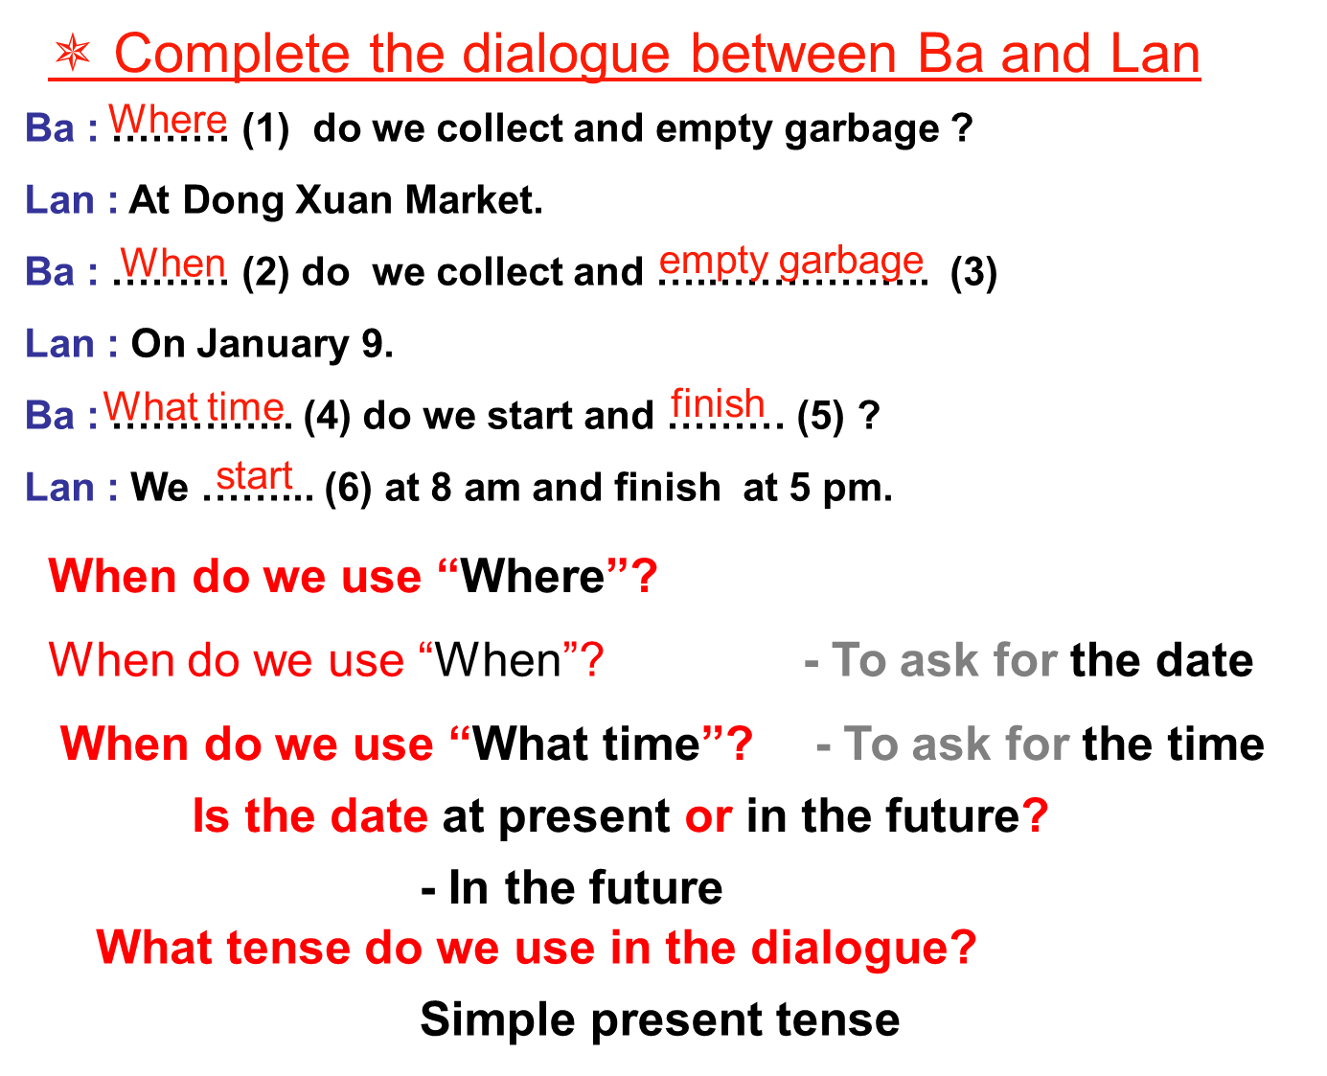

**Notes**: We use simple present tense to express an action that happen in the future

⮱ Simple tense with future meaning

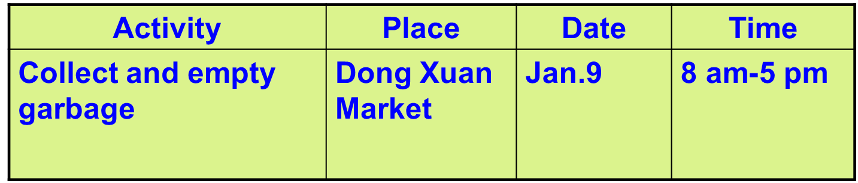

1/ Where do they collect and empty garbage ? At Dong Xuan Market

2/ When do they collect and empty garbage? On January 9

3/ What time do they start and finish work? They start at 8 am and finish at 5 pm

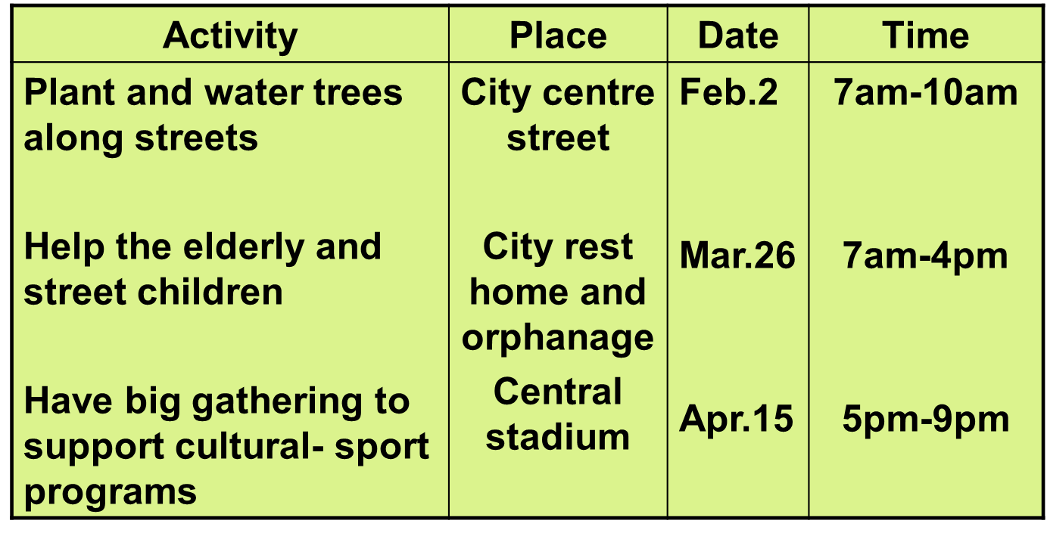

**GERUNDS**

**Ex:**

1. Ba loves playing soccer

2. Lan likes cooking meals

3. I hate playing soccer

4. They don’t like watching TV

5. She doesn’t like doing homework

**Note:**

**V + ing = Gerunds**

**Form:**

**hate**

**S + like + V-ing**

**love**

|  |  |  |  |  |  |  |  |  |
| --- | --- | --- | --- | --- | --- | --- | --- | --- |
|  | **BA** | | | | **LAN** | | | |
|  | **love** | **like** | **Don’t like** | **hate** | **love** | **like** | **Don’t like** | **hate** |
| Playing soccer | **√** |  |  |  |  |  | **√** |  |
| Washing up |  |  | **√** |  |  |  | **√** |  |
| Cooking meals |  |  |  | **√** |  | **√** |  |  |
| Performing music |  | **√** |  |  |  | **√** |  |  |
| gardening |  |  | **√** |  |  |  | **√** |  |
| Gathering broken glasses |  | **√** |  |  |  | **√** |  |  |
| Watching TV |  | **√** |  |  | **√** |  |  |  |
| Camping | **√** |  |  |  |  | **√** |  |  |
| Playing badminton |  |  |  | **√** |  |  | **√** |  |
| Doing homework |  | **√** |  |  |  |  |  | **√** |

* Ba loves playing soccer, but he doesn’t like washing up.
* Lan doesn’t like playing soccer and she doesn’t like washing up, either.

* Put the correct form of the verbs in banks :

1. She likes ……………… (plant) flowers in the garden.

2. They hate ……………… (do) housework.

3. My mother loves ……………… (play) football.

4. I like ……………… (get) up late on Sunday mornings.

**MODALS : CAN, COULD, MAY**

EX:

She can cook meals

She could cook meals when she was ten

I can’t play soccer

Can/ Could you help me?

**Structure:**

**(+) S + Modals + V-infi**

**(-) S + Modals + not + V-infi**

**(?) Modals + S + V-infi…?**

**Work with a partner.**

**1/ Use the expressions in the box to ask for a favor. The practice the dialogues with a partner**

help me with this math problem  
buy a ticket  
water the flower in the garden  
take me across the road

A. Woman: Can /Could you help me ,please?

Man: Yes, certainly.

Woman: Can you_____________________?

B. Old woman: Could you do me a favor?

Boy: What can I do for you?

Old woman: Can you______________________?

C. Boy: I need a favor.

Girl: How can I help?

Boy: Could you_____________________________?

D. Grandpa: Can you help me ,please?

Niece: Yes, Of course.

Grandpa: Can you___________________________?

**2/ Use useful expressions in the boxes to complete the dialogues. Then practice the dialogue with a partner.**

A/ Mom : ………………………….. me , Nam ?

Nam : Sure, Mom. ……………………….. for you ?

Mom : I want some potatoes. ……………………… buy

them for me?.

Nam : ………………….. I’ll go and buy soon.

**B/**Minh : Oh ! It’s too high

Lan : Do …………………….……?

Minh : Yes, . …………………… get that book? It’s too high.

Lan : ………………. Here you are

Minh : Thanks. …………………………… of you.

Rewrite

Present tense with future meaning

* The bus (leave) at 08:00 am on Tuesdays.
* The examination (start) at 9 o’clock tomorrow.
* The train (leave) for Paris at 10:00 pm.
* I leave London at 3 o’clock and I (arrive) in Paris at 10 o’clock.
* The lesson (start) at nine every day.
* Hurry up! The plane (depart) in 5 minutes.
* The program (start) every day at 10:30 am on weekdays.
* The bus (go) at half past 5 pm.
* When the concert (begin)?
* There’s no need to hurry. The bus ( not come) for another 15 minutes.
* My brother (come) tomorrow.
* The plane (leave) at 10:30 in the evening.
* The film (start) at 8 o’clock every week.
* She (make) an appointment with Dr Thomas tomorrow.
* The festival (start) on April 15th and closes on May 15th.